Assignment 3 Part A
Problem Statement :- Create a Node.JS Application which serves a static website.
Steps :-
- Open VSCode Editor -> Open a new folder Pract6 in VSCode editor.
- Open Command Prompt from this location in Windows Explorer.
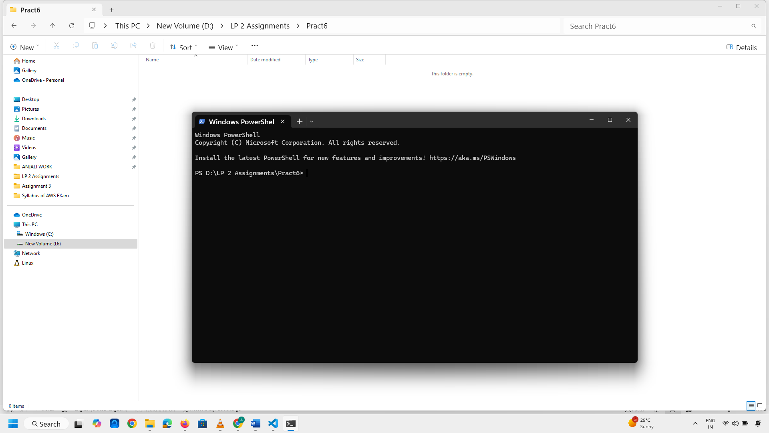
- Type npm init command on command prompt.
Few Questions will asked then answer them.
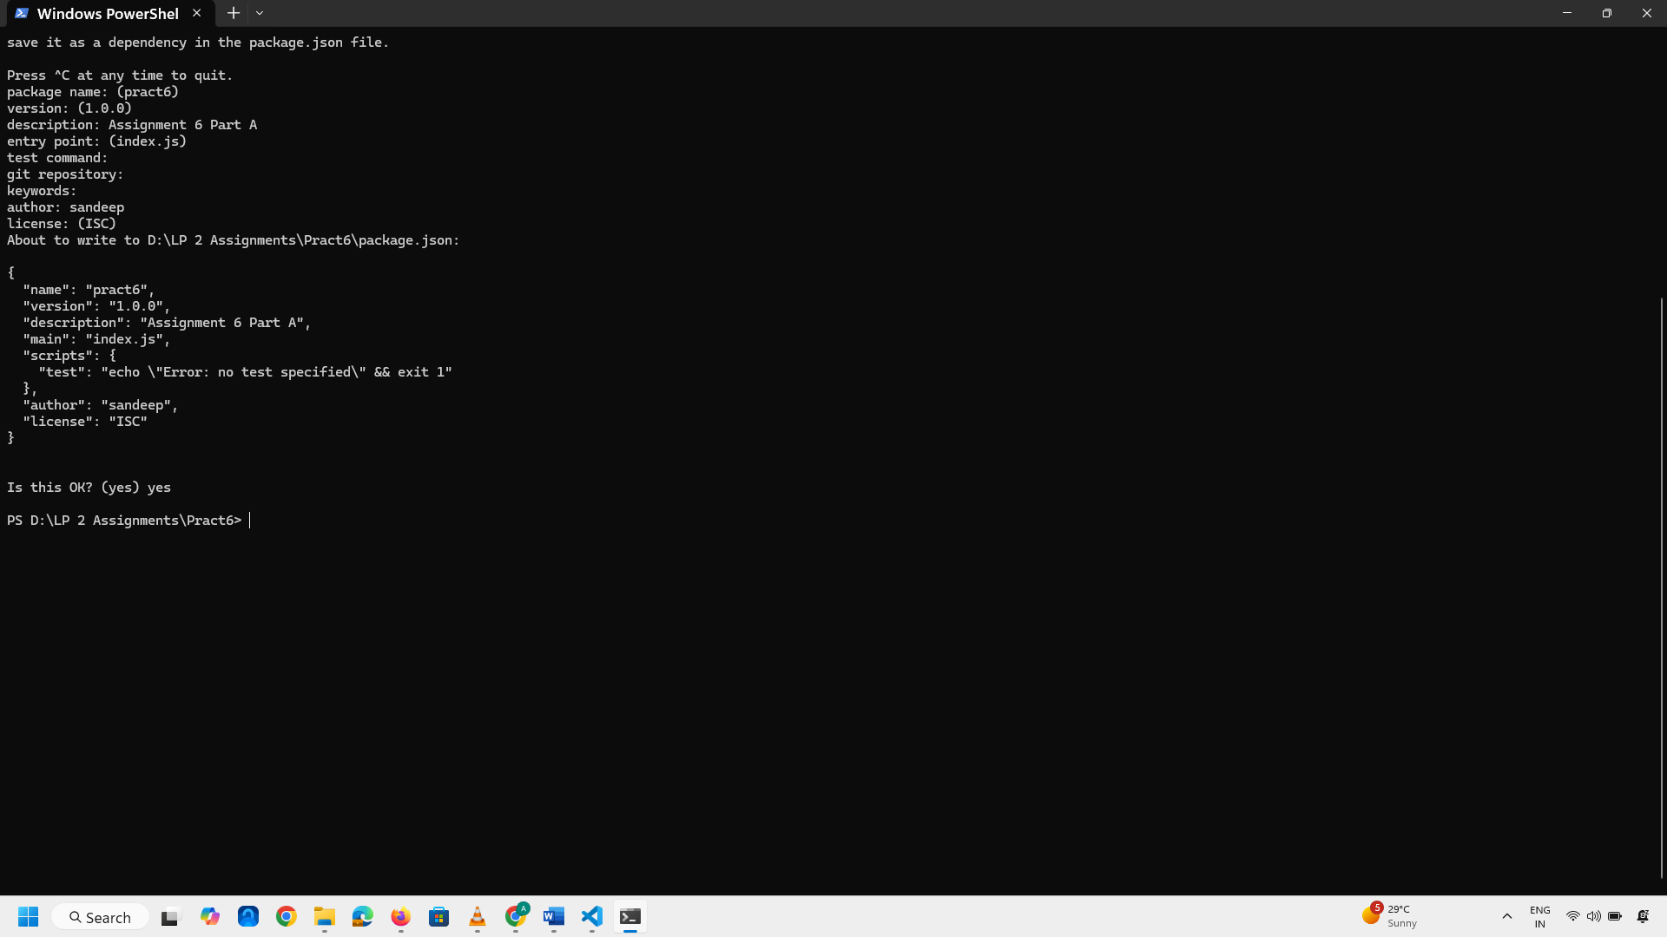
- Package.json file will be generated automatically.
- Create a new file index.js in vscode editor
- Go to command prompt execute following command npm install express –save. This will take some time to install as per your internet connectivity speed.
- This will create a new folder structure named node_modules 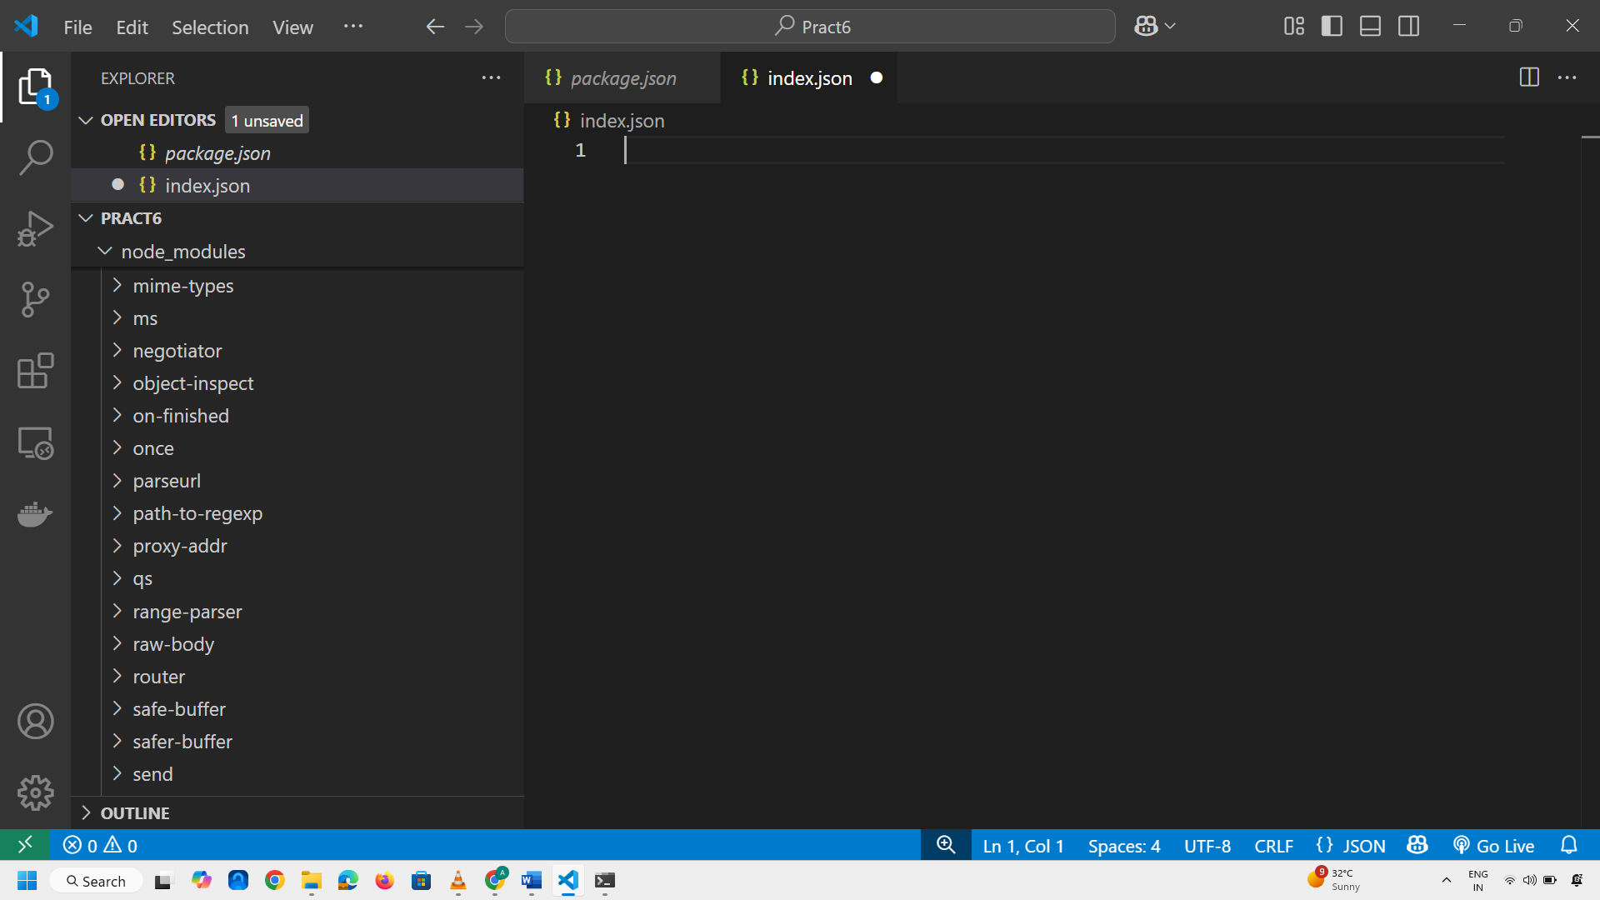
- Type the line of code as const express= require('express');
const app = express();
- Now Create a new folder with name public in the folder create index.html In this file create a file type html to get boiler code i.e., typical basic html code.
- Go into body part type h1 for heading Type Text as This is a Static Web Page.
- Now Open index.js file then type following code on line 3 app.use(express.static('public')) app.listen(4000,()=>{
console.log("Server has Started");

})

